5000 Brittonfield Parkway* Suite A 128
East Syracuse, NY 13057
(315) 446-4400 phone * (315) 446-4201 fax

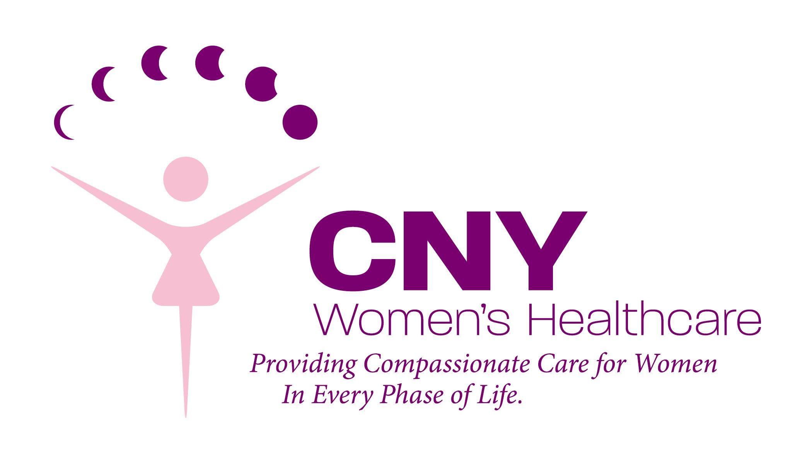

By initialing below, I am indicating that I have been given an opportunity to read the policies, relevant to me, set forth by CNY Women’s Healthcare. I understand that I may, at any time, request a copy of any or all of these policies.

Blood Transfusions (signature required on 2nd page)
CNY Women’s Healthcare Providers
Medical Information Release/ Assignment of Benefits
Notice of Privacy Practices (HIPAA Policy)
__________ Notice of Patient Bill of Rights

By signing this form, I acknowledge that I have been advised of all applicable policies.

Patient Signature Date

Patient Name (printed) and Date of Birth

____________________________________
Office Staff Witness Signature Date

5000 Brittonfield Parkway* Suite A 128
East Syracuse, NY 13057
(315) 446-4400 phone * (315) 446-4201 fax

Blood Transfusions
Obstetrics and Gynecology is a medical specialty where patients can experience
sudden and severe hemorrhage. This loss of blood can be very large and in these
situations a blood transfusion can be lifesaving.

It is never the policy of the physicians at CNY Women’s Healthcare to administer
blood transfusions unless absolutely necessary. Also, except in extreme emergencies,
the reason for a transfusion would certainly be explained to the patient beforehand.
However, the physicians in this office could never agree to care for a patient who would refuse a blood transfusion under any circumstances (Religious belief included). To not allow a blood transfusion removes a valuable method of treatment and places the physician in the unacceptable ethical position of possibly having a patient die from hemorrhage whose life could have been saved by blood transfusion.

Therefore, before you can be seen as a patient at our office, we request that you initial and sign the form given to you at check in and sign this form indicating that blood transfusions are an acceptable form of treatment (copy of this policy is also in the binder given to you at check in).

Signature of Patient and Date of Birth Date

Please Print Name Office Staff Witness Initials

** A copy of this form is available upon request, please ask a receptionist **

5000 Brittonfield Parkway* Suite A 128
East Syracuse, NY 13057
(315) 446-4400 phone * (315) 446-4201 fax

MEDICAL APPOINTMENT CANCELLATION/NO SHOW POLICY

Thank you for trusting your medical care to CNY Women’s Healthcare. When you schedule an appointment with CNY Women’s Healthcare, we set aside enough time to provide you with the highest quality care. Should you need to cancel or reschedule an appointment please contact our office as soon as possible, and no later than 24 hours prior to your scheduled appointment. This gives us time to schedule other patients who may be waiting for an appointment. Please see our Appointment Cancellation/No Show Policy below:
• Any established patient who fails to show or cancel/reschedule an appointment and has not contacted our office with at least 24 hours’ notice will be considered a No Show and charged a $25.00 fee.
• Any established patient who fails to show or cancel/reschedule an appointment with no 24-hour notice a second time will be charged a $50.00 fee.
• If a third No Show or cancellation/reschedule with no 24-hour notice should occur the patient may be dismissed from CNY Women’s Healthcare.
• A 72-hour notice is required for any surgery/procedure cancellation, or a $100 cancellation fee will be charged to your account.
• Any new patient who fails to show for their initial visit will be charged a No-Show fee of $50.00. This must be paid prior to making another appointment. If a new patient No Shows a new patient appointment for the second time their visit will not be rescheduled.
• The fee is charged to the patient. These fees are considered Non-Covered services by ALL insurance carriers and are due and payable by you. The fee is due at the time of the patient’s next office visit.
• As a courtesy, when time allows, we make reminder calls for appointments. If you do not receive a reminder call or message, the above Policy will remain in effect.
We understand there may be times when an unforeseen emergency occurs, and you may not be able to keep your scheduled appointment. If you should experience extenuating circumstances, please contact our office. You may contact CNY Women’s Healthcare at the number below Monday through Friday 8am to 4:30pm.

CNY WOMEN’S HEALTHCARE (315) 446-4400
5000 Brittonfield Parkway, Ste A128 East Syracuse, NY 13057

I have read and understand the Medical Appointment Cancellation/No Show Policy and agree to its terms.
_________________________________ _______________________________
Signature (Parent / Legal Guardian) Relationship to Patient

_________________________________ ________________________________
Printed Name Date

CNY Women’s Healthcare
5000 Brittonfield Parkway * Building A, Suite 128
East Syracuse, NY 13057
Phone (315) 446-4400 * Fax (315) 446-4201

Patient Demographics

Last Name First Name Middle Int.
Social Security # Date of Birth
Street Address
City State Zip
Primary Phone # Alt. Phone #
Email Address
Primary Care Physician Phone #
Pharmacy Name Phone #

RELEASE OF INFORMATION TO Relative / Friend
The following named person(s) may have access to all information (please circle all that apply) from CNY Women’s Healthcare regarding my care (I understand that I may add or remove names from list at any time)

medical, billing, appointment information, emergency basis

* I do not wish any of my information to be shared with anyone at this time (please initial)

Name Relationship
DOB Ph #
Name Relationship
DOB Ph #
Name Relationship
DOB Ph #
Name Relationship
DOB Ph #

* I give permission to CNY Women’s Healthcare to send appointment information to my email above _________ (please initial)

Patient name (printed) date

Patient signature office staff witness (initials and date)

CNY Women’s Healthcare

5000 Brittonfield Parkway* Suite A 128
East Syracuse, NY 13057
(315) 446-4400 phone * (315) 446-4201 fax

__________________________________________ ____________________
Patient Name Date of Birth

Financial Policy (revised 6/2023)

The providers at CNY Women’s Healthcare are here to serve your healthcare needs and are dedicated to providing you the best care possible. The intent of this policy is to clarify the role of the patient and the provider regarding billing issues. We ask that you CAREFULLY read and initial after reading each policy regardless if applicable.

- RELATIONSHIP:
Our relationship is with you, the patient, not your insurance company. Care will be administrated to you based on medical necessity, not according to what is covered under your health insurance policy. Because there are numerous insurance companies that have many product lines, it is the patient’s responsibility to know the benefits/coverage and requirements of their health insurance plan. Any questions regarding coverage and/or payments of claims should be addressed directly to your insurance company. This can be an overwhelming process so at any time you need help, we would be glad to assist you but ultimately it is your responsibility.

Int __________

- INSURANCE CHANGES:
It is your responsibility to inform staff of any and all insurance changes. You will be expected to present your current insurance information at each visit. If you have changed insurances you must provide a copy of your new card. If you have lost coverage you will need to notify staff immediately. Failure to disclose this information will be reason to be discharged from the practice.

Int __________

- LOSS OF INSURANCE COVERAGE:
In the event that you lose your insurance, you must notify the billing office immediately. Our office does NOT participate with Medicaid. In the event you lose your insurance you will be responsible to pay out of pocket at time services are rendered and for any fees that are incurred the day of your visit. After that you will need to either transfer care or seek a Medicaid HMO that we accept. Our obstetrical patients will pay for delivery fees ahead of time. In the event that you cannot pay out of pocket for services rendered at the time of service, you will need to transfer your healthcare to another practice.

Int __________

Office Staff Witness __________

CNY Women’s Healthcare

Patient Name: ____________________________________________ Chart# __________________________

- WE DO NOT PARTICIPATE WITH OR ACCEPT MEDICAID OR PCAP. However, we do participate with the following Medicaid Managed Care Plans:
- Fidelis
- Molina
- United Healthcare Community Plan
If you have Medicaid as a secondary insurance, you will be responsible for any balance not covered by your primary insurance company.

Int __________

- PATIENTS WHO LOSE THEIR INSURANCE WILL BE GIVEN 30 DAYS TO OBTAIN NEW COVERAGE UNDER A NEW PLAN WITH WHICH THE PRACTICE PARTICIPATES AND ACCEPTS. Failure to do so may result in the patient being discharged from the practice. The patient will be responsible for any charges or fees incurred until the new coverage becomes effective. Payment will be due at the time service is rendered.

Int __________

- METHODS OF PAYMENTS:
The practice accepts Cash, Checks, and Credit Cards for your convenience. There will be a $35.00 returned check fee for any returned checks.

Int __________

- COPAYS, COINSURANCE AND DEDUCTIBLES:
According to your insurance plan, YOU are responsible for ANY and ALL copayments, co-insurances and deductibles. All current and prior patient balances including coinsurance and deductibles are due at the time of service. Service will not be performed unless is received.

Int __________

- LATE ARRIVAL POLICY:
A late arrival is defined when a patient arrives more than 15 minutes late. Arriving late will cause the patient to be rescheduled at a later time and date to accommodate other patients on the schedule who arrived on time. Repeat offenders may be discharged from care.

Int __________

- STATEMENT FEE:
A $10.00 statement fee will be charged to your account in the event that you do not pay your co-pay at the time of your visit.

Int __________

Office Staff Witness_________

CNY Women’s Healthcare

Patient Name: ____________________________________________ Chart# __________________________

- CHARGES INCURRED OUTSIDE OF OUR OFFICE:
If your visit includes lab tests, anesthesia, biopsies, pap smears or cultures you will receive separate billing from the company performing the processing and evaluation of those tests. It may take as long as 4 weeks to receive those bills. If you receive medical care during a hospital inpatient or outpatient encounter, you may receive separate bills from the hospital, the anesthesia department and other healthcare providers involved in your care. Any questions related to these bills cannot be answered by this office and will need to be directed to the billing entity. If you need to have your labs sent to a specific laboratory please notify our office before a test is performed.

Int __________

- FORMS:
There is a $15.00 administration fee that is required for filing out and processing any paperwork, including but not limited to: Disability, Workers Compensation, FMLA, and No Fault.

Int __________

- WELL WOMAN (Preventative) AND PROBLEM FOCUSED EXAMS:
A Well Woman exam is when a healthy patient is seen to screen for various illness and diseases: This is considered preventative medicine. A problem visit is one where the patient has a specific concern, symptom, or complaint. We are required to submit claims based on the services you receive. If we provide both, Well Woman and a Problem Focused Exam then both services may be billed to your insurance company. Depending on your insurance coverage, some or all of the cost may have to be billed to the patient. We recommend you contact your insurance carrier prior to each visit and inquire about the type of benefits you have. Once a claim has been submitted to your insurance carrier, the office will not change the coding in order to circumvent an insurance denial as this may be considered insurance fraud.

Int __________

- SURGERIES:
As a courtesy to our patients, we check the surgical benefit with your insurance company prior to the procedure being performed in our office or at the hospital. Again this is a courtesy and we advise you to check your insurance coverage/benefits as well. We will also check the anesthesia benefits for an in office procedure just to give you an estimate of how much you will owe for the anesthesia portion of the procedure. Anesthesia is supplied by CNY Anesthesia; they will bill your insurance company separately for their services. CNY Women’s Healthcare is ultimately NOT responsible for any hospital, surgical or anesthesia charges. It is up to the patient to know their insurance policy and benefits.

Int __________

- PATIENT PAYMENTS:
All in-office surgeries/procedures will be pre-certified prior to the date of service. Benefits will be quoted by the insurance company based on your contract. Your co-insurance and/or deductible are REQUIRED to be paid in FULL the day of the procedure. Failure to pay your financial portion of your bill will result in your surgery/procedure to be postponed and/or rescheduled until paid in full.

Int __________
Office Staff Witness

CNY Women’s Healthcare

Patient Name: ____________________________________________ Chart# __________________________

- BAD DEBT POLICIES
- DELINQUENT ACCOUNTS:
Accounts that are delinquent for more than 60 days and have not been assigned payment arrangements with the practice are subject to interest charges of 1.3% per month.

Int __________

- PATIENT BALANCES OVER 120 DAYS:
Patient’s, who do not make reasonable progress toward paying outstanding obligations to the practice may at the sole discretion of the physician, be discharged from the practice. If a patient has been discharged from the practice they will be given thirty (30) days notice at which time they may request emergent medical services only. Patients will still be financially responsible for their account balances. Patients with a balance over 120 days will be sent to a Collection Agency and will be reported to the three (3) National Credit Bureaus. All accounts sent to collections will have a 20% collection fee charged to their account balances. Patients will be responsible for all attorney and collection fees the practice may encounter in collecting their outstanding balance.

Int __________

I, _____________________________________________________, have read this four (4) page document and understand my financial obligations to CNY Women’s Healthcare. I agree to all the terms and conditions.

Patient Name (Print):

Patient Signature: Date:

Guarantor Name: Date:
Guarantor Signature:
Relationship to Patient:

Office Staff Witness

06/2023

