5000 Brittonfield Parkway* Suite A 128
East Syracuse, NY 13057
(315) 446-4400 phone * (315) 446-4201 fax

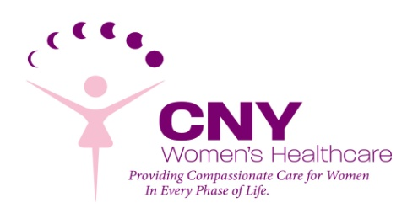

CNY Women’s Healthcare Providers

I understand that as an Obstetrical patient of CNY Women’s Healthcare, I am required to see all providers in the practice for my Obstetrical Care. This includes all Physicians: (Dr. Stephen M. Brown, Dr. Mary Ann Doan, Dr. Maria Ciciarelli, Dr. Jaya R. Nemani and Dr. Sarah Schoch-Storie) and all Nurse Practitioners: (Maria Gigante-Baggett, ANP, Kaitlin Corona, FNP, Mindy Valenti, FNP and Laura Borowski, FNP) as well as our Physician Assistant Jessica Hays, RPA-C during my pregnancy.

I understand that all five (6) physicians, the three (4) nurse practitioners and our physician assistant provide coverage for each other and therefore may be involved in my Gynecological care if my regular provider is not available or I am having an emergency.

I understand that my appointment may get moved to a different provider’s schedule without notice if there are urgent or last minute changes in our office schedules.

If I refuse to have any of the Physicians care for me during delivery, or in the event of emergency including emergency surgery, I understand that I will need to seek care at another practice to continue my Obstetrical and/or Gynecological Care.

I further understand that Drs. Brown, Doan, Ciciarelli, Nemani and Schoch-Storie provide Obstetric and Surgical care and share call for all patients of the office at Crouse Hospital in Syracuse, NY.

Therefore, before you can be seen as a patient at our office, we request that you initial and sign the form, indicating that you have been advised of this information and agree to this manner of care.

